Chapter 16 Multiple Choice Sample Questions

1. The ability of a microorganism to cause disease is referred to as:

a) Etiology

b) Infection

c) Pathogenicity

d)Pathogenesis

e) None of the above

2. True or False: Normal microbiota, or the permanent residents of our bodies are localized to internal tissues.

a) True

b) False

3. The term “Competitive exclusion” describes the process by which:

a) Members of the normal microflora produce anti-microbial substances that prevent the growth of human pathogens

b) Phagocytic granulocytes produce extracellular enzymes to digest invading microorganisms

c) Opportunistic pathogens cause disease when the host is in a weakened state

d) Members of the normal microflora use up available nutrients preventing growth of pathogens

e) None of the above

4. *Clostridium difficile* is famous for causing:

a) Urinary tract infections

b) Pneumonia

c) Salmonellosis

d) Causing severe inflammation in the colon after antibiotic treatment

e) None of the above

5. The amount of toxin required to cause death in 50% infected individuals is termed:

a) ID50

b) Kochs postulates

c) LD50

d)Toxicity

e) None of the above

6. True or False. A disease that spreads from one host to another is referred to as non-communicable.

a) True

b) False

7. True or False. When an infection spreads through-out the body this infection is referred to as systemic.

a) True

b) False

8. What statement is correct regarding endotoxins:

a) They are proteins secreted by bacteria

b) Botulinum toxin is an example

c) They are Lipopolysaccharides that are part of the outer membrane on gram negative bacteria

d) Salmonellosis, a food borne illness, is caused by endotoxins.

e) a, b and c

f) a, b, and d

g) c and d

**Examine the graph shown below to answer the following**

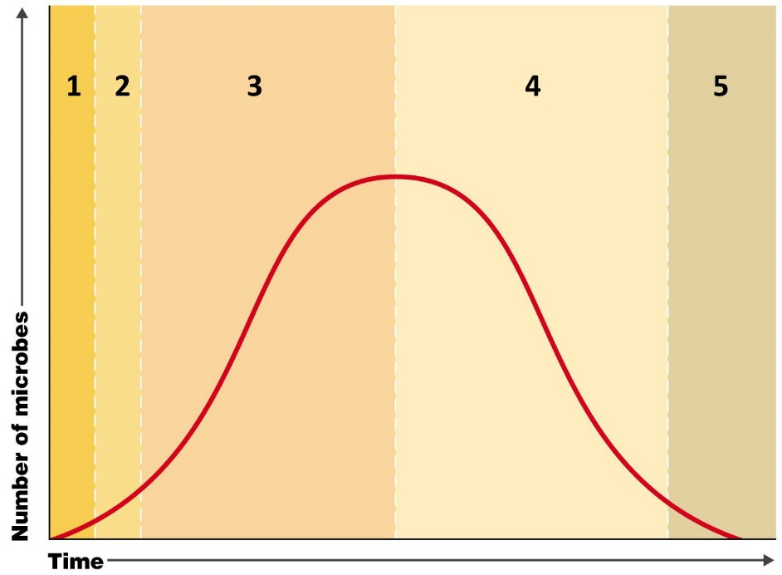

10. The graph shown above tracks the number of microbes present over time, during a typical illness, and shows that a typical illness can be divided into five distinct stages. During which of the numbered stages shown on the graph would you expect a patient to be susceptible to a secondary infection?

a) Stages 1 and 2

b) Stages 2 and 3

c) Stage 4

d) Stage 5

11. True or False: The ability of a pathogen to invade and multiply in the host tissues are related to the production of exoenzymes and invasins.

a) True

b) False

12. True or False: The gastrointestinal tract is the most common portal of entry for pathogens.

a) True

b) False